**LT #1: Exponential Models/Graphs**

/11

1. ___________________
2. ____________________
3. ___________________
4. ___________________
5. ___________________

*Target decides to discount any clothing that has been in its store for more than one month. In an effort to clear the items from inventory, Target drops the price by 7% each week.*

1. What is the multiplier used to model the situation? *(1 pt)*

*A population of bacteria has an initial population of 1200 and grows by 13% every hour.*

1. What is the multiplier for the population of bacteria? *(1 pt)*
2. Write an equation to model the population of the bacteria. Use your equation to determine the population of bacteria after 5 hours. Please round to the nearest whole number. *(2 pts)*

*You invest $3000 at an annual interest rate of 7%. Determine the amount in the account rounded to the nearest dollar after 10 years if the interest is compounded:*

1. Quarterly *(2 pts)*
2. Continuously *(2 pts)*

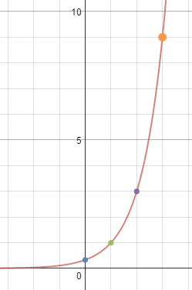**The graph on the right follows the formula**

6. ____________________  
  
  
  
7. ____________________

8. ____________________

1. What is the value of a? *(1 pt)*
2. What is the value of b? *(1 pt)*



1. Which function grows fastest? *(1 pt)*
   1. 
   2. 
 $y={2.5}^{x}$

  3. 