LT #1: Introduction to Polynomial Functions
1. Given the graph below of the polynomial function:
1.
a. # of Turning Points: _______
b. End Behavior:
On the right, the graph ______
On the left, the graph, _______
c. # of zeros: ______
d. Odd Even
(circle one)

2.
a. Degree: ____________

Terms: ______________

b. End Behavior:
On the right, the graph _______
On the left, the graph ________
c. # of zeros: ______

d. # of turning points: _____
/11
  - How many turning points does the function have? (1 point)

  - Describe its end behavior. (2 points)

  - How many zeros does this function have? (1 point)

  - Identify if this function is odd or even. (1 point)

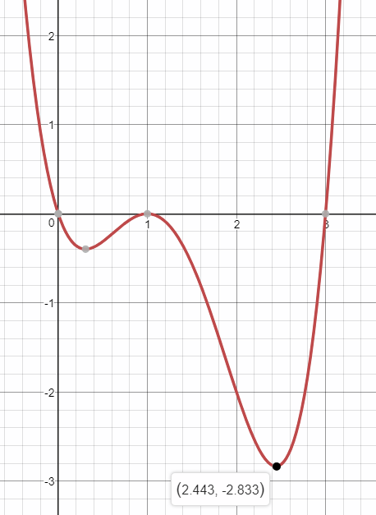

- $f\left(x\right)=-2x^{4}+3x-1$
  - Classify f(x) both by its degree and its number of terms. (2 points)
  - Describe the end behavior of f(x). (2 points)
  - How many zeros could f(x) have? (1 point)
  - How many turning points could f(x) have? (1 point)

