**LT #5: Using Linear Models**

1. Which correlation coefficient would best represent the scatter plot of data?

(2 pts each)

1. ____________

2. _____________

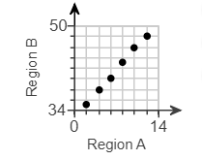

a. r = -.97   
b. r = -.12   
c. r = .23   
d. r = .96

/4

2. Describe the correlation given a correlation coefficient of r = -.94

a. Strong, negative   
b. Weak, negative   
c. Strong, positive   
d. Weak, positive

**LT #6: Families of Functions (Transformations)**

State the transformations on the following functions. Then graph the   
function, using the transformations. (4 pts each)

16. 17.

 

/8