LT #7: Complex Numbers
Simplify the follow. (2 points each)
1. ___________________

2. ___________________

3. ____________________

4. _____________________

5. ______________________

6.
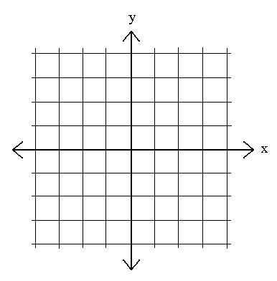
/13
- $i^{35}$ 2. $\left(3+2i\right)\left(4-3i\right)$

3. $\frac{2-i}{3+i}$ 4. $\left|-4+3i\right|$

Solve using the quadratic equation. (3 points)
5. $x^{2}+5x+10=0$

6. Graph the complex number 2+3i. (2 points)

